Conditions of use:
- The template is only to be used for Consultants who require a 1099. It may be used for USG or non-USG awards. For organizations not expecting a 1099, use a purchase order template.
- Areas highlighted in Yellow are directions or language that you need to choose from. Directions (in red) and language not used need to be deleted.
This “conditions of use” section to be deleted in the final award

Independent Consultant Agreement

Section I: Consulting Agreement Data

Consultant Agreement Number:

PARTNERS Authorized Technical Representative:

PARTNERS Authorized Administrative/Contractual Representative:

Consultant Name and Address:
Period of Performance: | Start Date: | End Date:
Consultant Agreement Ceiling Price: |  | Currency
Consultant Agreement Hourly Rate (if applicable): | (insert “Not Applicable” if this is a fixed price agreement
Type of Agreement | Choose an item.

Section II: Terms and Conditions

Article 1. Agreement Documents

- This Agreement is between Partners of the Americas, Inc, located at 1424 K Street NW, Suite 700, Washington, DC 20005, hereinafter referred to as “PARTNERS” and the CONSULTANT named in Section I (hereinafter referred to as "CONSULTANT"), whose address is named in Section I. This Agreement contains the entire understanding between PARTNERS and the CONSULTANT (the Parties) with respect to the subject matter hereof, and supersedes prior oral and written agreements between the Parties, and can only be modified by an instrument in writing executed by both Parties.

- This CONSULTANT Agreement is comprised of the body of this Agreement, Annexes A through G, and all documents incorporated therein by reference (the “Agreement”). These documents set forth the entire agreement between PARTNERS, and the CONSULTANT with regard to the subject matter of this Agreement.

Article 2. Exclusive Engagement

The CONSULTANT commits to perform the tasks specified in the Agreement only for the exclusive benefit of PARTNERS and shall not accept any other engagement from any known, or potential, business competitors of PARTNERS for similar work that may constitute a conflict of interest during performance of this Agreement.

Article 3. Term
PARTNERS agrees to engage CONSULTANT, and CONSULTANT agrees to provide the agreed-upon services for the period of performance specified in Section I.

Article 4. Scope of Work

- Under this Agreement, CONSULTANT will provide to PARTNERS the professional services set forth in the Scope of Work in Annex A. The CONSULTANT further agrees to perform his/her duties faithfully to the best of his/her ability, to comply with local laws and customs, and to conduct him/herself in a manner consistent with PARTNERS standards of business and program conduct.

- Performance under this contract will be reviewed monthly to make sure expected outcomes and deliverables are being accomplished.

- If a revision of the Scope of Work is determined, an exchange of notices between CONSULTANT and PARTNERS shall occur as defined in Article 10. Notices, indicating agreement on the nature, scope and cost of the revision or special project(s). These will be considered as approval and included as an addendum to this agreement.

Article 5. Compensation and Payment (Choose One)

Option 1 Labor Hour
- The CONSULTANT will bill PARTNERS, and PARTNERS will pay CONSULTANT based on an hourly rate identified in Section I, upon successful completion of Scope of Work In Annex A. The maximum total hours payable under this agreement as per Annex A.

- The CONSULTANT should submit invoices to PARTNERS on a monthly basis no later than thirty (30) days after the end of the previous month. PARTNERS agrees to pay the CONSULTANT for its invoices submitted within 30 days of receipt of a proper invoice provided that the requirements of this Agreement are being met by the CONSULTANT, including the submission of deliverables according to the schedule specified in Annex A. A proper invoice must include:
- The CONSULTANT’s name and complete address;
- Date of invoice;
- The CONSULTANT Agreement Number;
- The period covered by the invoice;
- For Labor Hour Agreements: The CONSULTANT must itemize the services rendered by hours or days, specify the dates the work was performed, and indicate the total amount to be paid. Attachment 1 contains a sample invoice template and a Microsoft excel version is available upon request.
- If Reimbursable Costs are authorized as per Annex A, the CONSULTANT must itemize the reimbursable costs specifying the dates the costs were incurred, purpose of the cost, and attach receipts for the claimed costs or PARTNERS may decline to pay the costs.

Option 2 Fixed Price
- The CONSULTANT will bill PARTNERS, and PARTNERS will pay CONSULTANT based upon successful completion of the Deliverables specified in the Scope of Work In Annex A.

- The CONSULTANT should submit invoices to PARTNERS no later than the 30 days following the completion of services. PARTNERS agrees to pay the CONSULTANT for its invoices submitted within 30 days of receipt of a proper invoice provided that the requirements of this Agreement are being met by the CONSULTANT, including the submission of deliverables according to the schedule specified in Annex A. A proper invoice must include:
- The CONSULTANT’s name and complete address;
- Date of invoice;
- The CONSULTANT Agreement Number;
- The period covered by the invoice;
- For Fixed Price Agreements, the CONSULTANT’s itemized breakdown of claims shall be in accordance with the deliverables payment schedule set forth in Annex A. Payment shall be subject to receipt, acceptance and approval of the specified deliverables
- If Reimbursable Costs are authorized as per Annex A, the CONSULTANT must itemize the reimbursable costs specifying the dates the costs were incurred, purpose of the cost, and attach receipts for the claimed costs.
- Attachment 2 contains a sample invoice template and a Microsoft excel Version is available upon request.

- Invoices shall be submitted to (insert here).
- PARTNERS will promptly review invoices submitted to determine whether they are proper invoices are not. Invoices determined to be proper will be paid by PARTNERS within thirty (30) days after approval of a proper invoice. Invoices determined not to be proper due to the existence of deficiencies will be returned to CONSULTANT, generally within ten (10) business days of submission, with major deficiencies noted for correction. In the event that an invoice is submitted which is partly proper and partly not proper, PARTNERS may, in its sole discretion, pay only the amount deemed proper and decline payment for the not proper portions.

Article 6. Travel and Other Expenses

CONSULTANT will comply with all PARTNERS rules and regulations on travel. PARTNERS will compensate CONSULTANT for approved travel, meals and incidental expenses (M&IE), lodging, and other expenses as specified in Annex A.

Article 7. Data Rights

- The CONSULTANT hereby grants and assigns to PARTNERS all rights, title, and interest worldwide to all products (papers, manuscripts, notes), data, or any other information or materials (e.g., photographs, graphic presentations, manuals or log, work, or processing instructions) created or developed by the CONSULTANT for PARTNERS under this Agreement.

- A manuscript prepared under this Agreement shall be a work made for hire within the meaning of the Copyright Act of 1976. PARTNERS shall hold all rights to the manuscript without limitation and may register the copyright in its name.

- The CONSULTANT may use CONSULTANT’s materials to perform work under this Agreement. The CONSULTANT shall retain all rights, title, and interest, including all copyright, patent rights and trade secret rights to CONSULTANT’s materials created and developed by the CONSULTANT outside of this Agreement.

Article 8. Taxes

The CONSULTANT accepts responsibility for all personal local, state, federal, social security, and other taxes or fines that he/she may incur as a result of the CONSULTANT’s performance of obligations hereunder. PARTNERS is not responsible for withholding or paying local, state, or federal taxes for this personal/consulting service. It is the responsibility of the CONSULTANT to pay local taxes in his/her country.

Article 9. Termination

- This agreement may be terminated by Partners at any time, with or without cause, provided that PARTNERS gives CONSULTANT written notice of such intention to terminate of at least TEN (10) business days. Should the CONSULTANT be terminated for misconduct, dereliction of duty, appearing on a list of individuals who are prohibited from providing services to donors or to clients of PARTNERS, or gross failure to perform satisfactorily (collectively, “cause”), or should CONSULTANT voluntarily resign without obtaining prior written consent of PARTNERS, PARTNERS will not be liable for any fee or related costs beyond the date of agreement termination.

- This Agreement may be terminated by the CONSULTANT provided the CONSULTANT gives PARTNERS written notice of at least THIRTY (30) calendar days. The CONSULTANT will promptly reimburse PARTNERS for all prepaid expenses or advances unless such reimbursement is expressly waived by PARTNERS.

- Force Majeure Circumstances: Neither PARTNERS nor CONSULTANT shall be liable for the violation of its obligation hereunder, if such violation is caused due to military actions, violations of public order, prohibitory acts of government, fires, floods, epidemics, or other circumstances which cannot be foreseen and have Force Majeure character, being beyond reasonable control. The party is released from liability for any such violation during the period of the Force Majeure circumstances if the other party is immediately notified in writing concerning the existence of such circumstances. In the case where Force Majeure circumstances continue to exist for more than 60 days, either of the parties can terminate this Agreement.

Article 10. Notices

- Any and all official notices, designations, consents, offers, acceptances or other communication required to be given under this Agreement shall be in writing, and delivered by email with reply confirmation, or in person or sent by registered or certified mail, postage prepaid, to the following addresses:

- Name: (insert here).
Address: (insert here).
Phone Number: (insert here).Fax: (insert here).
Email: (insert here).
- CONSULTANT Contact Information in Section I.

- The foregoing addresses may be changed and/or additional persons may be added thereto by notifying the other Party hereto in writing and in the manner herein set forth. All notices shall be effective upon receipt.

Article 11. Applicable Governing Law

This Agreement shall be governed by and construed in accordance with the laws of the District of Columbia without regard to the conflict of laws principles thereof.

Article 12. Validity and Waiver

The invalidity in whole or in part of any provision of this agreement shall not affect the validity of other provisions. A waiver of a breach of any provision of this agreement shall not constitute a waiver of any subsequent breach of that provision or a breach of any other provision of this agreement. The failure of PARTNERS to enforce at any time or from time to time any provision of this agreement shall not be construed as a waiver thereof.

Article 13. Changes

- By written order, PARTNERS may from time-to-time direct changes for technical requirements, place of delivery, inspection or acceptance, reasonable adjustments in quantities, delivery schedules or both; and terms and conditions of this contract required to meet PARTNERS’s obligations.

- If any such change(s) causes an increase or a decrease in the cost, or the time required for the performance of any Agreement under this Agreement, an equitable adjustment shall be made in the Agreement price or delivery schedule, or both, and the Agreement shall be modified in writing accordingly. Any claim by the CONSULTANT for adjustment under the Agreement must be asserted within 30 (thirty) days from the date of receipt by the CONSULTANT of the modification or change.

Article 14. Assignment and Delegation

This Agreement may not be assigned or delegated, in whole or in part, by the CONSULTANT without the written consent of PARTNERS. In case of such absent consent, any assignment is voided.

Article 15. Inspection and Acceptance

- PARTNERS reserves the right to inspect or test services delivered by the CONSULTANT as a result of this Agreement. PARTNERS will exert good faith efforts to decide on acceptance of services (and, as applicable, to complete inspection and testing) as promptly as possible upon delivery/performance.

- If CONSULTANT delivers non-conforming Services, PARTNERS may, at its option and CONSULTANT’s expense:

- require CONSULTANT to promptly correct or replace the Services;
- correct the nonconformance; or
- reduce the contract price to reflect the reduced value of the services performed.

- PARTNERS shall specify the reason for any return or rejection of nonconforming Services and/or shall describe the action taken. CONSULTANT shall be liable for any increase in costs, including labor and expenses, attributable to PARTNERS’s rejection of the non-conforming Services.

- PARTNERS may require replacement or re-performance of nonconforming services at no increase in Agreement price. If replacement or re-performance will not correct the defects or is not possible, PARTNERS may seek an equitable price reduction or adequate consideration for acceptance of nonconforming commodities or services. PARTNERS will exercise its post-acceptance rights within a reasonable time after the defect was discovered or should have been discovered.

- If the CONSULTANT fails to promptly perform the services again or to take the necessary action to ensure future performance in conformity with contract requirements, PARTNERS may terminate the contract for default.

Article 16. Independent Contractor Status

CONSULTANT is, and shall remain, an independent contractor during the performance of this Agreement.

Article 17. Severability

If any court of competent jurisdiction determines that any provision of this agreement is invalid or unenforceable, such a determination shall not affect the remaining provisions of this agreement. Further, each valid provision under this agreement shall be enforced to the fullest extent permitted by law.

Article 18. Restriction on Public Disclosure and Publicity

No news release, public announcement, denial, or confirmation of any part of the subject matter of this Agreement shall be made without the prior written consent of PARTNERS. The restrictions of this article shall continue in effect upon completion or termination of this Agreement for such period of time as may be mutually agreed upon in writing by the parties. In the absence of a written established period, no disclosure is authorized.

Article 19. Anticorruption Provisions

- The CONSULTANT shall conduct all activities related to this engagement in a fair, honest, and transparent manner.

- CONSULTANT represents and certifies that CONSULTANT rejects corruption in all of its forms, including Bribery, making a Facilitation Payment or any Prohibited Act.

- CONSULTANT represents and certifies that CONSULTANT is aware that Bribery is a crime under a host of anticorruption statutes, including the Bribery Act, the Criminal Code Act, the FCPA and similar statutes, and therefore, strictly prohibited, regardless of jurisdiction or circumstance.

- CONSULTANT shall not directly or indirectly commit or attempt to commit any Prohibited Act, including Bribery or making a Facilitation Payment.

- CONSULTANT represents and certifies that CONSULTANT shall comply with Partners Code of Conduct or with its own Code of Conduct, and that this code does not conflict with PARTNERS Code of Conduct.

- The CONSULTANT nor has not:

- made or offered any unlawful payment, or offered or promised to make any unlawful payment, or provided or offered or promised to provide anything of value (whether in the form of property or services or in any other form), to any foreign or domestic official or employee of any Governmental Entity (which, for the purposes of this section, also includes any political party or candidate), or to any finder, agent, representative or other party acting for, on behalf of, or under the auspices of any official or employee of any Governmental Entity (each, a “Government Official”) for purposes of unlawfully (i) influencing any act or decision of any Government Official in his or her official capacity, (ii) inducing any Government Official to do or omit to do any act in violation of his or her lawful duty, (iii) securing any improper advantage; or (iv) inducing any Government Official to influence or affect any act or decision of any Governmental Entity, in each case for the purpose of obtaining or retaining business or directing business to any person;
- used any funds for unlawful contributions, gifts, entertainment, or other unlawful expenses relating to political activity or
- taken any other action or made any omission that would or would reasonably be expected to result in a violation of the Foreign Corrupt Practices Act of 1977, as amended, and the rules and regulations thereunder, or any other law of the United States, or of any other jurisdiction where the CONSULTANT conducts business governing corrupt practices, commercial bribery, money laundering, pay-to-play, anti-bribery or anticorruption or that otherwise prohibits payments to any government or public officials or employees.

- CONSULTANT shall include these, or substantially similar, anticorruption provisions in all subcontracts or other agreements CONSULTANT makes in connection with this engagement.

Article 20. Communication with Partners, Donors, Clients

The CONSULTANT will not propose or advocate to any official or employee of counterpart organization, or any donor agency any activity or course of action with direct impact on PARTNERS unless agreed to in advance by the PARTNERS in writing. CONSULTANT will not communicate directly with a donor about his or her work on PARTNERS without the written consent of PARTNERS.

Article 21. Dispute Resolution

The Parties shall first attempt to resolve any dispute arising under this Agreement by informal discussions between the Parties, subject to good cause exceptions, including, but not limited to, disputes determined by either Party to require immediate relief (i.e., circumstances which may result in a misappropriation of federal funds). Any dispute that has failed to be resolved by informal discussions between the Parties within a reasonable period of time after the commencement of such discussions (not to exceed thirty (30) days), may be resolved through any and all means available under applicable law.

Article 22. Indemnity

To the fullest extent permitted by law, the CONSULTANT shall indemnify and hold harmless PARTNERS and its officers, directors, employees, agents, and legal representatives, from and against any and all claims, demands, liabilities, expenses (including reasonable attorney's fees and disbursements, court costs, judgments, settlements and fines), whether of omission or commission, that may be committed or suffered in connection with the performance of this Agreement by the CONSULTANT or the CONSULTANTs general business operations. This paragraph shall survive the termination or expiration of this Agreement

By signature below, each signatory hereto represents and warrants that they are duly authorized to enter this Agreement on behalf of the party he or she purports to represent such that, upon execution and delivery, this Agreement shall be a binding obligation of such party. CONSULTANT acknowledges and warrants that prior to signing, CONSULTANT has read this Agreement in its entirety and was afforded reasonable time to consider the Agreement. Execution by either party of a facsimile copy of this Agreement will be deemed to constitute effective execution of this Agreement by that Party.

For Partners of the Americas: |  | For the Consultant:
Name |  | Name
Date: |  | Date:

Annex A- CONSULTANT Scope of Work

Part I. Introduction and Objectives

(Provide a background statement about the Prime Award SOW and objectives of the CONSULTANT’s Work

Part II. Technical Direction, Management and Communication

The Authorized Technical Representative identified in the Contract may give directions to the Vendor that fills in details, suggest possible lines of inquiry, or otherwise complete the general scope of work. The technical directions must be within the terms of this Contract and shall not change or modify the terms in any way.

The Authorized Technical Representative is authorized to accept reports and deliverables.

All terms and conditions or modifications thereof which involve prices, quantities, quality, and schedule will be made only by the PARTNERS Administrative/Contractual Representative

Part III. Statement of Work

(Insert SOW here. If the Prime Award SOW is used, this contract must state what tasks or assignments are to be performed by the consultant. These tasks should be consistently identified with the work breakdown structure of the overall work plan/technical approach for the project.)

Part IV. Schedule of Deliverables

Reporting Requirements  (Activities and/or Outputs and language in which all reports shall be delivered) | To be Completed by no later than these Due Dates | Delivery Instructions  (# of copies, paper/electronic transmittals, formats, names of reviewers, etc.) | Fixed Price (Currency) (not required if hourly)

Part V. Administrative Guidelines
Maximum Number of Hours Authorized | (Not required if fixed price)
Total Amount of Expenses Authorized | Currency
Travel Authorized | If travel is authorized, PARTNERS will issue a separate Travel Authorization Letter specifying specify travel destination, dates, per diem, and number of days authorized.
Travel and Transportation (if applicable) | Round-trip, economy class airfare, by the most direct route will be provided in accordance with PARTNERS Travel Regulations. CONSULTANT will be reimbursed for actual transportation costs. Original airline passenger receipts, boarding passes, and itinerary must be submitted to PARTNERS with the expense report regardless of who purchased the ticket.
Other Out-of-Pocket Expenses | PARTNERS authorizes the following out of pocket expenses:  Insert  Insert  CONSULTANT will be reimbursed for actual expenses supported by receipts, upon approval by PARTNERS. CONSULTANT is liable for all unauthorized expenses and must maintain complete records of charges submitted to PARTNERS. CONSULTANT will not be reimbursed for personal or non-project expenses (i.e., telephone calls, copying, etc.).
Completion of Expense Report | Claims for expenses must be recorded on the Consultant Invoice submitted to PARTNERS with appropriate documentations. Actual receipts are required. If a receipt is unobtainable (e.g., metro, some taxis), an affidavit in lieu of receipt must be completed. Receipts are not required for items less than USD $25. If traveling, the original passenger receipts, boarding passes, and itinerary must be submitted, even if PARTNERS purchased the ticket for the CONSULTANT.

Part VI. Special Conditions

(Insert any special contract requirements from the Prime Contract that should be particularly noted by the consultant. For Example: use of government or contractor property, marking and branding requirements, etc.

ANNEX B- Partners of the Americas Code of Conduct

No code or policy can anticipate every situation that may arise. Accordingly, this Code is intended to serve as a source of guiding principles. Partner of the Americas (Partners) reserves the right to make all decisions on a case-by-case basis.

Introduction
Each employee, volunteer, consultant and representative and member of the Partners Network is expected to adhere to a high standard of ethical conduct. The good name of Partners of the Americas depends on the way its network and representatives conduct business and the way the public perceives that conduct. Unethical actions, or the appearance of unethical actions, are not acceptable.

Confidentiality
All persons interacting with or representing the Partners Network should maintain the confidentiality of information entrusted to them by Partners of the Americas and any other confidential information about the organization, its activities, partners, funders, stakeholders, or suppliers, that comes to them, from whatever source, except when disclosure is authorized or legally mandated.

International Activity
Partners of the Americas conducts operations and activities around the world. Many of the countries where Partners conducts business have laws and regulations that may be significantly different from those of the US. Persons interacting with or representing Partners in a foreign country are responsible for knowing and complying with these laws. Furthermore, anyone interacting with or representing the Partners Network must also take care to understand and respect the cultures and customs of the countries where Partners operates.

Anyone working in the international arena should be aware of the US Foreign Corrupt Practices Act. The Act prohibits giving anything of value to officials of foreign governments in order to obtain or retain business. It is prohibited for any representative of Partners of the Americas or its network to engage in bribery, kickbacks, payoffs, or other corrupt business practices. It is also Partners of the Americas’ policy to fully comply with all applicable US export, customs and trade control and regulations, licensing/ trademarking/ copyright requirements and other relevant US and international laws.

Harassment
Partners of the Americas intends to provide a pleasant, healthful, comfortable, and professional atmosphere that is free from intimidation, hostility or other offenses which might interfere with the pursuit of our mission. Moreover, Partners does not tolerate discrimination on the basis of sex, race, color, age, religion, disability, national origin, sexual orientation, or any other legally prohibited characteristic.

Harassment or discrimination based on sex, or any other legally prohibited basis is illegal and is contrary to the policy of Partners.

Compliance
If you know of or suspect a violation of applicable laws, rules or regulations or this Code, you must immediately report that information to any Senior Manager or member of the International Board of Partners of the Americas, Inc. They could also contact Partners confidential hotline at +1 (443)-951-4951. The President or Chairman of the Board shall determine, or shall designate appropriate persons to determine, appropriate action in response to violations of this Code.

Partners of the Americas prohibits any retaliation against anyone who makes a good faith report of a suspected violation or who participates in an investigation. There is to be no interference, coercion, discrimination, reprisal, or retaliation against any person for making a valid and truthful complaint or good faith report of a violation. Nothing in this policy is meant to, nor should it be interpreted to, in any way limit your rights under any applicable federal, state, or local laws.

By signing below, I certify that I have read and understood the statement written above.

Signature: Date:

Printed Name:

ANNEX C- Statement of Confidentiality of Corporate Affairs

The nature of Partners’ work makes it essential that employees do not divulge proprietary company information unless expressly authorized by an officer of the company. All inquiries about Partners’ corporate policies or details of our business or work products are to be referred to or reviewed with an officer of the company. Unless authorized by a company officer, employees may not reveal details of Partners’ clientele and contracts.

Use of Proprietary and Confidential Information
Partners’ employees and independent contractors may have access to and become acquainted with proprietary and confidential information such as client lists, rates, financial records, internal structure, internal policies, publications, inventories, computer software and related documentation and similar information, which is owned by Partners, and which is regularly used in the operation of the business of the company. I agree not to use such proprietary or confidential information obtained during employment or contractual relationship with Partners as a means of making private profit.

Nondisclosure of Proprietary or Confidential Information
I recognize and acknowledge that certain information concerning Partners’ business is a valuable, special, and unique asset of the company. I agree not to disclose Partners’ proprietary or confidential information to any person or entity for any reason, except as required in the course of employment or contractual relationship, or required by law or court order; and further agree not to make use of such information for my own benefit or the private benefit of others.

Ownership of Property
All files, records, documents, drawings, specifications, equipment, and similar items relating to the business of Partners, including computer software or software documentation, whether prepared by me or otherwise coming into my access or possession, shall remain the exclusive property of Partners and shall not be reproduced, removed, or transmitted from the premises of the company under any circumstances without the prior written consent of the company. Upon termination of employment with Partners, I will return all company property to my supervisor or a company officer.

I agree that if any trade secret, formula, device, technology, technical information, process, etc. (“invention”) is made by me during the course of my employment or contractual relationship, alone or jointly with others which is made with Partners’ equipment, supplies, facilities, trade secrets or time, or which relates to the business of Partners, or which results from any work performed by me for Partners, such invention will belong to Partners and Partners will have full authority to use, transfer or license it. I agree that Partners will have the right to keep such invention as a trade secret if it so chooses. I further agree to assign to Partners my rights in any invention where the company is required to grant those rights to the United States Government. It is further agreed that Partners is not required to designate me as the inventor or author of any such invention if it is distributed publicly or otherwise.

I understand that violation of this policy is cause for immediate dismissal or termination of contractual relationship and/or demand for financial restitution to Partners for damages to the limit allowed by law.

Conflict of Interest Policy

The following Conflict of Interest Policy has been adopted by the Partners of the Americas Boards of Directors. Each board member, officer, employee, and Independent Contractor of Partners must sign this statement annually to reflect the absence of any relationships or financial interests described in the policy or disclose any which do or may exist.

“Contracts or transactions
- between Partners and one or more of its board members, officers, or employees, or
- between Partners and any corporation, partnership, association, or other organization in which one or more of its board members, officers or employees are directors or officers, or have a financial interest, shall not be void or voidable solely for this reason, or solely because the board member, officer or employee is present at or participates in any meeting which authorizes the contract or transaction, or solely because his, her, or their votes are counted for such purpose, if:
  - The material facts regarding the relationship or interest are disclosed or are known to the Board of Directors, and the Board of Directors in good faith authorized the contract or transaction by the affirmative votes of a majority of the disinterested board members or officers, even though the disinterested board members or officers may then become less than a quorum; or
  - The material facts regarding the relationship or interest are disclosed or are known to the Board of Directors and officers voting thereon and the contract or transaction is specifically approved in good faith by a vote of the Board of Directors; or
  - The contract or transaction is fair to Partners as of the time it is authorized, approved, or ratified by the Board of Directors.

Common or interested Board members or officers may be counted in determining a quorum at any meeting of the Board of Directors which authorizes the contract or transaction, provided, however, that the interested person or persons shall be excluded from the room during the discussion of the contract or transaction in question and during the vote thereon.”

By signing below, I certify that I have read and understood the statement written above.

Signature: Date:

Printed Name:

Annex D - Productive Work Environment/Sexual Harassment

Partners intends to provide for its employees, and non-employees (such as interns, volunteers, consultants, and independent contractors), a work environment that is pleasant, healthful, comfortable, and free from intimidation, hostility or other offenses which might interfere with their performance. Harassment of any sort – verbal, physical, environmental – is prohibited by this policy and will not be tolerated. Moreover, Partners will not tolerate harassment by any employee, non-employee, or member of the Partners network.

Partners does not tolerate discrimination on the basis of sex, race, color, creed, age, religion, disability, national origin, or any other legally prohibited characteristic. Harassment based on sex, or any other legally prohibited basis is illegal and is contrary to the policy of Partners.

Partners will not tolerate verbal or physical conduct which harasses, disrupts, or interferes with work performance or which creates an intimidating, offensive or hostile work environment. In order to avoid circumstances where harassment becomes severe or pervasive, employees and non-employees should report all incidents of harassment immediately. While all forms of harassment are prohibited, Partners emphasizes that sexual harassment is specifically prohibited. Each employee and non-employee has the responsibility to ensure that the workplace is free of any form of sexual harassment. No Partners employees, non-employees or members of the Partners network shall threaten or insinuate, either explicitly or implicitly, that any person’s refusal to submit to sexual advances will adversely affect the work.

Other sexually harassing conduct in the workplace is also prohibited. Such conduct includes, but is not limited to: a) unwelcome sexual flirtations, touching, advances, or propositions; b) verbal abuse of a sexual nature; c) graphic or sexually suggestive comments; d) sexually degrading words to describe an individual; and e) the display, storage or transmission of sexually suggestive objects or pictures.

Harassment Complaint Procedure
If you believe you have been subjected to prohibited harassment or you are aware of any such conduct, the incident must be reported immediately, preferably in writing, to any supervisor or Senior Manager of Partners of the Americas. All complaints will be promptly and thoroughly investigated, and each complaint will be handled as confidentially as possible under the circumstances. Partners prohibits retaliation against any person who files a harassment complaint or cooperates with an investigation. Complaints will be investigated impartially and if found to be truthful, Partners will take immediate corrective action. Anyone found to have engaged in harassment will be subject to appropriate disciplinary action up to, and including termination.

Retaliation for Harassment Complaint
Partners prohibits any retaliation against anyone who legitimately exercise their rights under this policy or who participate in an investigation. There is to be no interference, coercion, discrimination, reprisal, or retaliation against any person for making a valid and truthful complaint or report of a violation. Any employees or non-employees who believe they are being discriminated against as a result of having legitimately filed a complaint or having truthfully participated in an investigation should immediately notify a member of management. Anyone who becomes aware of possible harassment or retaliation must immediately advise Partners of the Americas so it can be investigated in a timely and confidential manner.

This policy applies to all individuals when interacting with members of the Partners staff or network.

By signing below, I certify that I have read and understood the statement written above.

Signature: Date:

Printed Name:

ANNEX E -Non-Discrimination/Affirmative Action

Partners of the Americas is an equal opportunity employer. Partners does not discriminate regardless of actual or perceived race, creed, color, sex (including pregnancy, childbirth and other pregnancy-related conditions), religion, national origin, citizenship, sexual orientation, personal appearance, gender identity or expression, physical or mental handicap or disability, age (18 or over), marital status (including parenthood), family responsibilities, matriculation, genetic information, political affiliation, veteran status or any other areas of discrimination prohibited by applicable law. This policy applies to all terms, conditions, and privileges of employment including hiring, training and staff development, promotion, and compensation.

Partners promotes diversity and equal opportunity in the workplace in accordance with all applicable Federal and local law requirements.

Employees with questions or concerns about any type of discrimination in the workplace are encouraged to contact their supervisor. If you believe that you have been the victim of any type of discrimination or are aware of such conduct, you must promptly notify your supervisor or a Senior Manager of Partners. Employees may raise concerns and make reports without fear of reprisal. Anyone found to be engaging in any type of unlawful discrimination will be subject to disciplinary action, up to and including termination of employment.

Persons with Disabilities
As part of its commitment to a diverse workforce, Partners does not discriminate in its hiring or employment practices against qualified individuals with disabilities who can perform the essential job functions with or without reasonable accommodation. In compliance with the Americans with Disabilities Act, Partners adheres to the following guidelines:

- The application process is used solely to determine whether a candidate's qualifications and abilities reasonably match job requirements. Therefore, applicants are not queried about their physical condition or medical history (except where it appears that essential job functions could not be performed without accommodations, in which case only appropriate inquiries relating to functional limitations are made).
- Partners will make reasonable accommodations to enable a qualified individual with a disability to perform essential job functions, unless doing so will create an undue hardship.
- Employees who need a reasonable accommodation should inform their supervisor or a Senior Manager of Partners as soon as possible and Partners will engage in an interactive process with the employee to evaluate potential accommodations.

By signing below, I certify that I have read and understood the statement written above.

Signature: Date:

Printed Name:
ANNEX F -Sexual Exploitation and Abuse Prevention Code of Conduct

No code of conduct or policy can anticipate every situation that may arise. Accordingly, this code is intended to serve as a source of guiding principles and to complement already established policies, not to act as an exhaustive list. Individuals who work under awards that have their own codes of conduct on this subject are expected to abide by those codes as well. Partners of the Americas (POA) reserves the right to make all decisions on a case-by-case basis.

Sexual Exploitation & Abuse Prevention
POA is committed to providing a safe and supportive working environment, free from sexual abuse, exploitation, and harassment for all program beneficiaries (hereafter referred to as “Participants”) who attend or participate in programs, activities, and/or events sponsored by the organization. Sexual exploitation and abuse (SEA) of any sort – verbal or physical – is prohibited and will not be tolerated by POA. Moreover, POA will not tolerate acts of SEA by any employee, non-employee, members of the Board of Directors, members of a partner organization with a contractual relationship with POA, or members of the POA network, including but not limited to consultants, volunteers, and Chapter members implementing programs on behalf of POA (hereafter referred to as a “POA Affiliate”). This policy applies to all POA Affiliates interacting with Participants.
POA recognizes the unequal power dynamic that may exist between POA Affiliates and Participants, and therefore the potential for exploitation in its work. POA further recognizes that exploitation undermines the credibility of its work and severely harms victims of these exploitative acts and their families and communities. No POA Affiliate shall threaten or insinuate, either explicitly or implicitly, that any person’s refusal to submit to sexual advances will adversely affect them.

POA Affiliates will respond to Participants with respect, consideration, and equal treatment, regardless of sex, gender, race, religion, sexual orientation, culture, ability, or socio- economic status. POA Affiliates must conduct themselves in a professional manner as representatives of the organization, consistent with the standards for U.N. employees in Section 3 of the U.N. Secretary General’s Bulletin-Special Measures for Protection from Sexual Exploitation and Sexual Abuse (ST/SGB/2003/13). Thus, as a condition of their employment or engagement, POA Affiliates must acknowledge and agree to the following core principles which are consistent with Section 3 of the U.N. Secretary-General’s Bulletin (ST/SGB/2003/13):
- Sexual exploitation and abuse by a POA Affiliate constitute acts of gross misconduct and are therefore grounds for termination of employment and/or relationship.
- Sexual activity with children (defined according to the Convention on the Rights of the Child as all persons under the age of 18) is prohibited regardless of the age of majority or age of consent locally. Mistaken belief in the age of a child is not a defense.
- Exchange of money, employment, goods, or services for sex, including sexual favors or other forms of humiliating, degrading, or exploitative behavior, is prohibited. This includes exchange of assistance that is due to beneficiaries.
- Sexual relationships between POA Affiliates and Participants are prohibited since they are based on inherently unequal power dynamics. Such relationships undermine the credibility and integrity of humanitarian aid work.
- Where a POA Affiliate develops concerns or suspicions regarding sexual abuse or exploitation by another POA Affiliate, they must report such concerns via established organizational reporting mechanisms.
- POA Affiliates are obliged to create and maintain an environment that prevents sexual exploitation and abuse and promotes the implementation of this code of conduct. Managers at all levels have a particular responsibility to support and develop systems that maintain this environment.

SEA Complaint Procedure
If you believe you have been subjected to SEA or you are aware of any such conduct, the incident must be reported immediately. POA Affiliates must report all incidents or suspicions of SEA immediately through one of the means listed below.
- Contact the immediate supervisor, program, or country director of the alleged offender.
- Contact POA’s external and confidential hotline, Foster Thomas, at +1 (443)-951-4951. Foster Thomas is an outside party who will relay any concerns to the Ethics Committee of the Board. Reports may be made anonymously.
- Contact POA’s internal HR department at poahr@partners.net.
All complaints will be promptly and thoroughly investigated, and each complaint will be handled confidentially. Complaints will be investigated impartially and if found to be truthful, POA will take immediate corrective action. Anyone found to have engaged in SEA will be subject to appropriate disciplinary action up to and including termination.

Retaliation for SEA Complaint
POA prohibits any retaliation against anyone who legitimately exercises their rights under this policy, files a complaint, or participates/cooperates in an investigation. There is to be no interference, coercion, discrimination, reprisal, or retaliation against any person for making a valid and truthful complaint or report of a violation. Anyone who believes they are being discriminated against as a result of legitimately filing a complaint or truthfully participating in an investigation should immediately file a report through one of the ways mentioned above.

Anyone who becomes aware of possible harassment or retaliation must immediately file a report so that the organization can investigate in a timely and confidential manner. POA will take action against anyone, whether they are the subject of a complaint or not, who seek or carry out retaliatory action against complainants, witnesses, or victims. Employees may be subject to disciplinary action, up to and including termination of employment. Others who work with POA may have their relationship with POA terminated.

Please refer to the SEA Prevention Policy for further information and guidance.

I have read and agree to this policy. By signing below, I agree to abide by the above policies. I also agree to attend one of the SEA Prevention trainings/courses listed in the SEA Prevention Policy within 30 days of signing this Code of Conduct and again once annually thereafter.

Signature: Date:

Printed Name:

ANNEX G -Child Safeguarding Code of Conduct

No code of conduct or policy can anticipate every situation that may arise. Accordingly, this code is intended to serve as a source of guiding principles and to complement already established policies, not to act as an exhaustive list. Individuals who work under awards that have their own codes of conduct on this subject are expected to abide by those codes as well. Partners of the Americas (POA) reserves the right to make all decisions on a case-by-case basis.

Child Safeguarding
POA is committed to providing a safe, nurturing working environment and protecting children who participate in programs and/or events sponsored by the organization. POA is committed to supporting victims, improving safeguarding capacity, and ensuring that children are safe when participating in POA programs and/or events sponsored by the organization. Child Safeguarding is preventative actions to ensure that all children are protected from deliberate or unintentional acts that lead to the risk of or actual harm by POA Affiliates who come into contact with children or impact them through our development interventions, humanitarian responses, and operations. Moreover, POA will not tolerate any violations of this Child Safeguarding policy and confirms commitment to report, investigate, respond to any alleged policy violations. POA takes a zero-tolerance approach to child exploitation and/or abuse by any POA Affiliates. This policy applies to all POA Affiliates interacting with children.

POA’s current programs support activities with children, who are particularly vulnerable to abuse and exploitation. This is due to the inherent power differential that exists between aid organizations and impacted communities, which heightens the risk of abuse and exploitation. In order to protect all program beneficiaries against this power differential, the Child Safeguarding Policy, the Sexual Exploitation and Abuse Prevention Policy, and the Sexual Harassment Policy serve to transform POA’s values into behaviors to which all POA Affiliates are expected to conform.

POA’s capacity to achieve its vision and mission depends upon all POA Affiliates. Therefore, all POA Affiliates must uphold and promote the highest standards of ethical and professional conduct. POA prohibits any act of child abuse, child exploitation, child neglect, economic exploitation, bullying and cyberbullying, or ill treatment. The following core principles are to be followed by all POA Affiliates:
- All children under the age of 18 have equal rights to protection from all forms of violence, as declared in Article 19 of the United Nations Convention on the Rights of the Child. The human rights of children will be respected and applied to all, irrespective of age, sex, gender, gender identity, sexual orientation, nationality, ethnicity, color, race, language, religious or political beliefs, marital status, disability, physical or mental health, family, socio-economic or cultural background, class, or any other aspect of their background or identity. Inequality, exclusion, and discrimination will be challenged and will not be tolerated;

- Ensure compliance with host country and local child welfare and protection legislation or international standards, whichever gives greater protection, and with U.S. law where applicable;

- Prohibit all personnel from engaging in child abuse, exploitation, or neglect;

- Consider Child Safeguarding in project planning and implementation to determine potential risks to children that are associated with project activities and operations and identify gaps and ways to address;

- Apply measures to reduce the risk of child abuse, exploitation, or neglect, including, but not limited to, limiting unsupervised interactions with children; prohibiting exposure to pornography; and complying with applicable laws, regulations, or customs regarding the photographing, filming, or other image- generating activities of children;

- Promote child-safe screening procedures for personnel, particularly personnel whose work brings them in direct contact with children;

- Have a procedure for ensuring that personnel and others recognize child abuse, exploitation, or neglect; mandating that personnel and others report allegations; investigating and managing allegations; and taking appropriate action in response to such allegations, including, but not limited to, dismissal of personnel;

- Train all POA Affiliates to know how to report and who to contact when any concern arises, no matter how seemingly small or insignificant;

- Respond to concerns including a mandate to investigate all credible allegations violations of this Child Safeguarding Policy. POA Affiliates are required to cooperate with any subsequent investigation. Corrective measures, including any personnel or disciplinary action, will be taken to prevent the recurrence of such activity; and

- Ensure all POA Affiliates receive training and are made aware of the expectation in this policy in order to prevent, report, and respond to safeguarding concerns. Additionally, ensuring that all program beneficiaries are aware of the standards of behavior they can expect from POA Affiliates and of how they can raise a concern or report an alleged violation.

POA Affiliates are required to comply with the following code of conduct when interacting with children:

- Any individual under the age of 18 is a child and is “underage,” regardless of the legal age of consent of the country in which the child lives and/or in which the offense occurs;

- POA Affiliates must not abuse or exploit a child or behave in any way that places a child at risk of harm;

- Sexual activity with children (defined according to the Convention on the Rights of the Child as all persons under the age of 18) is prohibited regardless of the age of majority or age of consent locally. Mistaken belief in the age of a child is not a defense;

- POA Affiliates are prohibited from dating or becoming romantically involved with a child;

- POA Affiliates are prohibited from using language or behave towards a child or young person in a way that is inappropriate, offensive, abusive, sexually provocative, demeaning, or culturally inappropriate;

- POA Affiliates are prohibited from fondling, holding, kissing, hugging, or touching children in an inappropriate or culturally insensitive way;

- POA Affiliates are prohibited from acting in ways that shame, humiliate, belittle, or degrade children and young people, or otherwise perpetrate any form of emotional abuse;

- POA Affiliates are prohibited from doing things of a personal nature for children, with whom they are in contact in a work-related context (e.g., taking a child/young person to the toilet/bathroom; helping them get un/dressed);

- POA Affiliates are prohibited from sleeping in the same beds, sleeping bags, tents, hotel rooms, or other rooms with children unless the adult is an immediate family member of all children in the bed, sleeping bag, tent, hotel room, or other room. It is acceptable to have multiple adults sleep with all the children participating in one open space, such as a camp lodge. Furthermore, POA Affiliates are prohibited from having a child/children with whom the employee is in contact in a work-related context (program beneficiaries) stay overnight at their home or any other personal residential location or accommodation;

- POA Affiliates are prohibited from discussing their own sexual activities, including dreams and fantasies, or discussing their use of sexually oriented or explicit materials, such as pornography, videos, or materials on or from the Internet, with children;

- POA Affiliates are prohibited from possessing, viewing, streaming, downloading from the Internet, etc. any sexually oriented materials (magazines, cards, videos, films, clothing, etc.) on organization property or in the presence of children except as expressly permitted as part of a pre-authorized educational program;

- POA Affiliates are prohibited from using computers, mobile phones, or video/digital cameras or other electronic devices, to access, view, create, download, or distribute child pornography, including abusive images of children or young people;

- POA Affiliates are prohibited from using computers, mobile phones, video and digital cameras, or other electronic devices or mediums to exploit, harass, or bully children;

- POA Affiliates are prohibited from dressing, undressing, bathing, or showering in the presence of children;

- POA Affiliates are prohibited from discriminating against, showing differential or preferential to, or favoring particular children;

- POA Affiliates are prohibited from using physical punishment in any way for behavior management of children. No form of physical discipline is acceptable. This prohibition includes spanking, slapping, pinching, hitting, or any other physical force. Physical force may only be used to stop a behavior that may cause immediate harm to the individual or to a child or others;

- POA Affiliates are prohibited from the use, possession, distribution, or being under the influence of alcohol, illegal drugs, or the misuse of legal drugs while participating in or assisting with programs or activities specifically for children;

- Every program for children must have established ratios of 2 adults per 1-20 children. Compliance with the established ratio is required at all times, including activities that occur off the organization’s premises;

- When boys, girls and other gender identities are participating, male, female and other gender identities adults must be present;

- One-to-one counseling/meetings with children will be done in an open or public or other place where private conversations are possible but occur in full view of others or with another adult present;

- When supervising or assisting private activities, such as dressing or showering children, POA Affiliates will remain in an area observable by other adults or work in pairs;

- Parents or guardians must complete written permission forms before POA Affiliates transport children for a company sponsored activity or for any purpose; and

- Implement a safeguarding approach that recognizes and responds to the specific safeguarding risks and needs of differing gender and other identities including take appropriate measures to address gender bias and other forms of discrimination and violence which may arise as a result of this bias. All approaches should take full account of gender in considering the specific safeguarding needs of girls, boys, and other gender identities to promote equality, equity, and ultimately increase safety and protection.

Child Safeguarding Complaint Procedure
POA Affiliates must report all violations of the Child Safeguarding Policy immediately through one of the means listed below.
- Contact the immediate supervisor, program, or country director of the alleged offender.
- Contact POA’s external and confidential hotline, Foster Thomas, at +1 (443)-951-4951. Foster Thomas is an outside party who will relay any concerns to the Ethics Committee of the Board. Reports may be made anonymously.
- Contact POA’s internal HR department at poahr@partners.net.
All complaints will be promptly and thoroughly investigated, and each complaint will be handled confidentially. Complaints will be investigated impartially and if found to be truthful, POA will take immediate corrective action. Anyone found to have engaged in SEA will be subject to appropriate disciplinary action up to and including termination.

Retaliation for SEA Complaint
POA prohibits any retaliation against anyone who legitimately exercises their rights under this policy, files a compliant, or participates/cooperates in an investigation. There is to be no interference, coercion, discrimination, reprisal, or retaliation against any person for making a valid and truthful complaint or report of a violation. Anyone who believes they are being discriminated against as a result of legitimately filing a complaint or truthfully participating in an investigation should immediately file a report through one of the ways mentioned above.

Anyone who becomes aware of possible harassment or retaliation must immediately file a report so that the organization can investigate in a timely and confidential manner. POA will take action against anyone, whether they are the subject of a complaint or not, who seek or carry out retaliatory action against complainants, witnesses, or victims. Employees may be subject to disciplinary action, up to and including termination of employment. Others who work with POA may have their relationship with POA terminated.

Please refer to the Child Safeguarding Policy for further information and guidance.

I have read and agree to this policy. By signing below, I agree to abide by the above policies. I also agree to attend one of the Child Safeguarding trainings/courses listed in the Child Safeguarding Policy within 30 days of signing this Code of Conduct and again once annually thereafter.

Signature: Date:

Printed Name:

Attachment 1
Consultant Invoice for Labor Hour Agreements
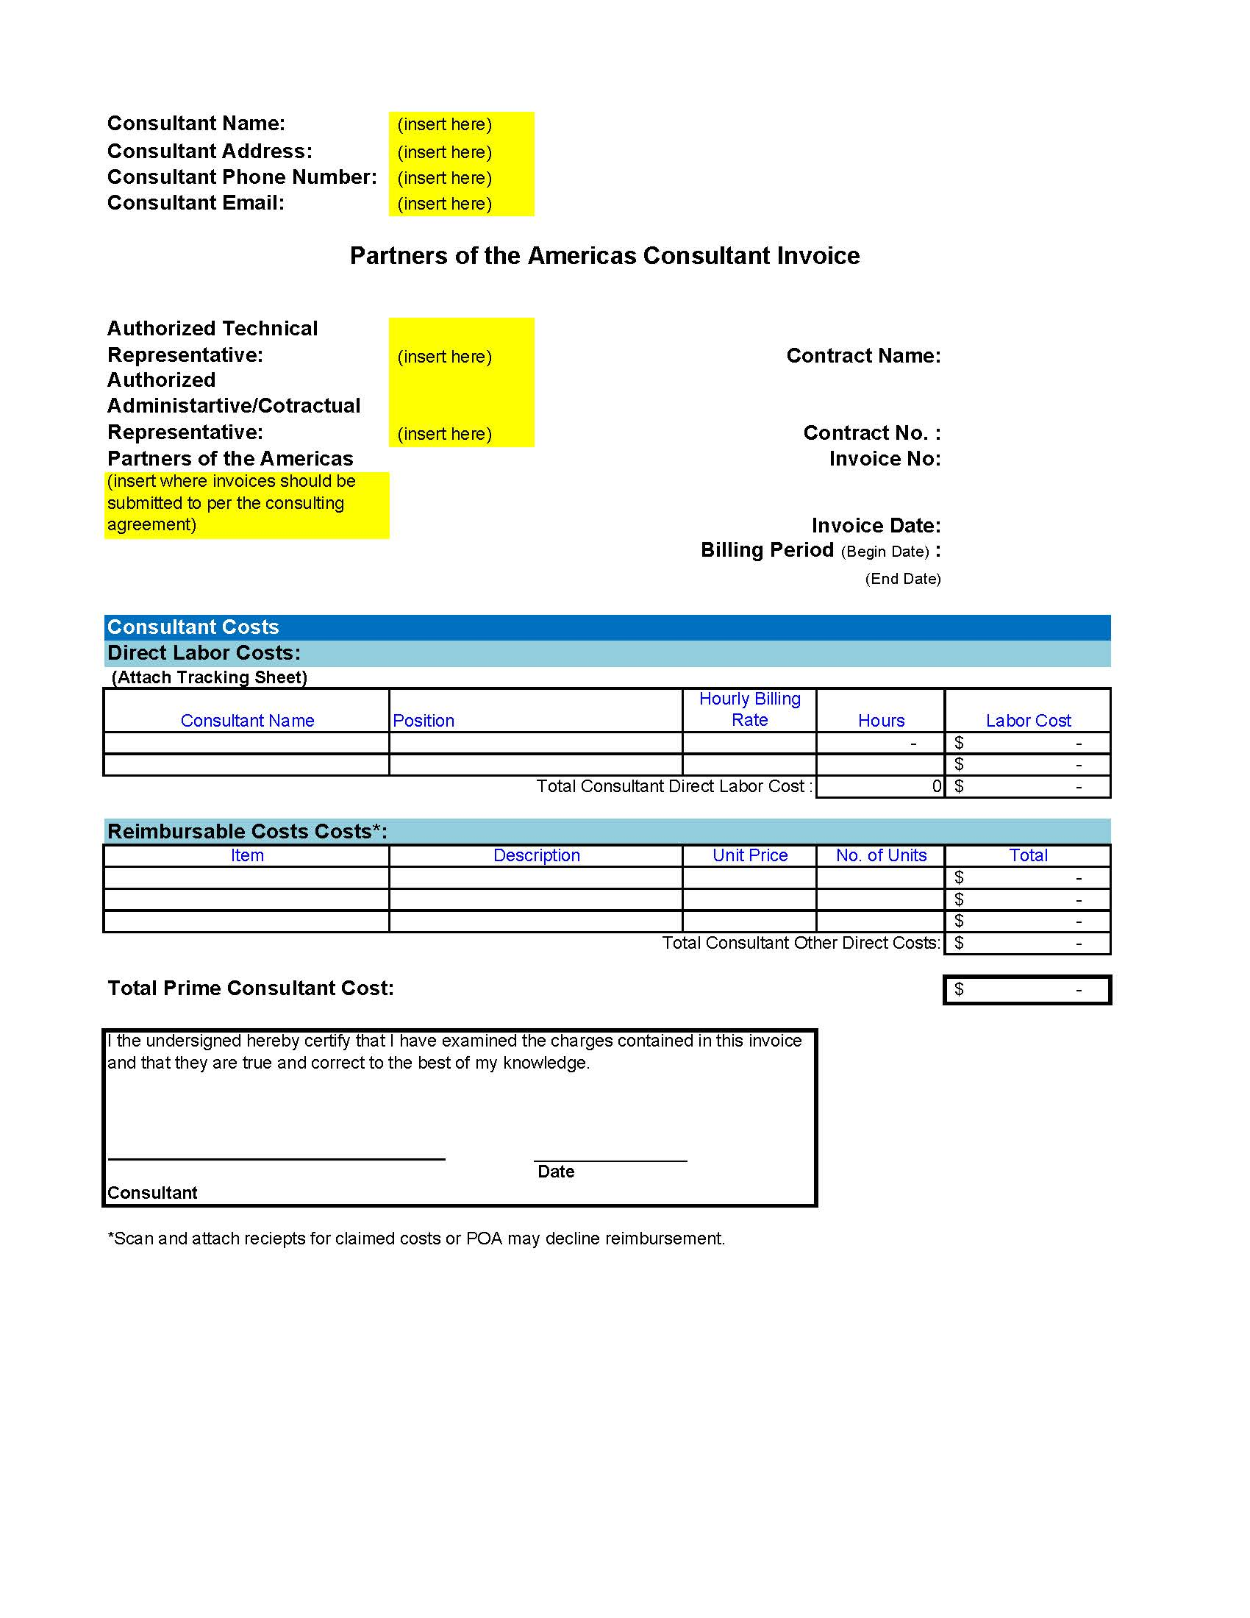
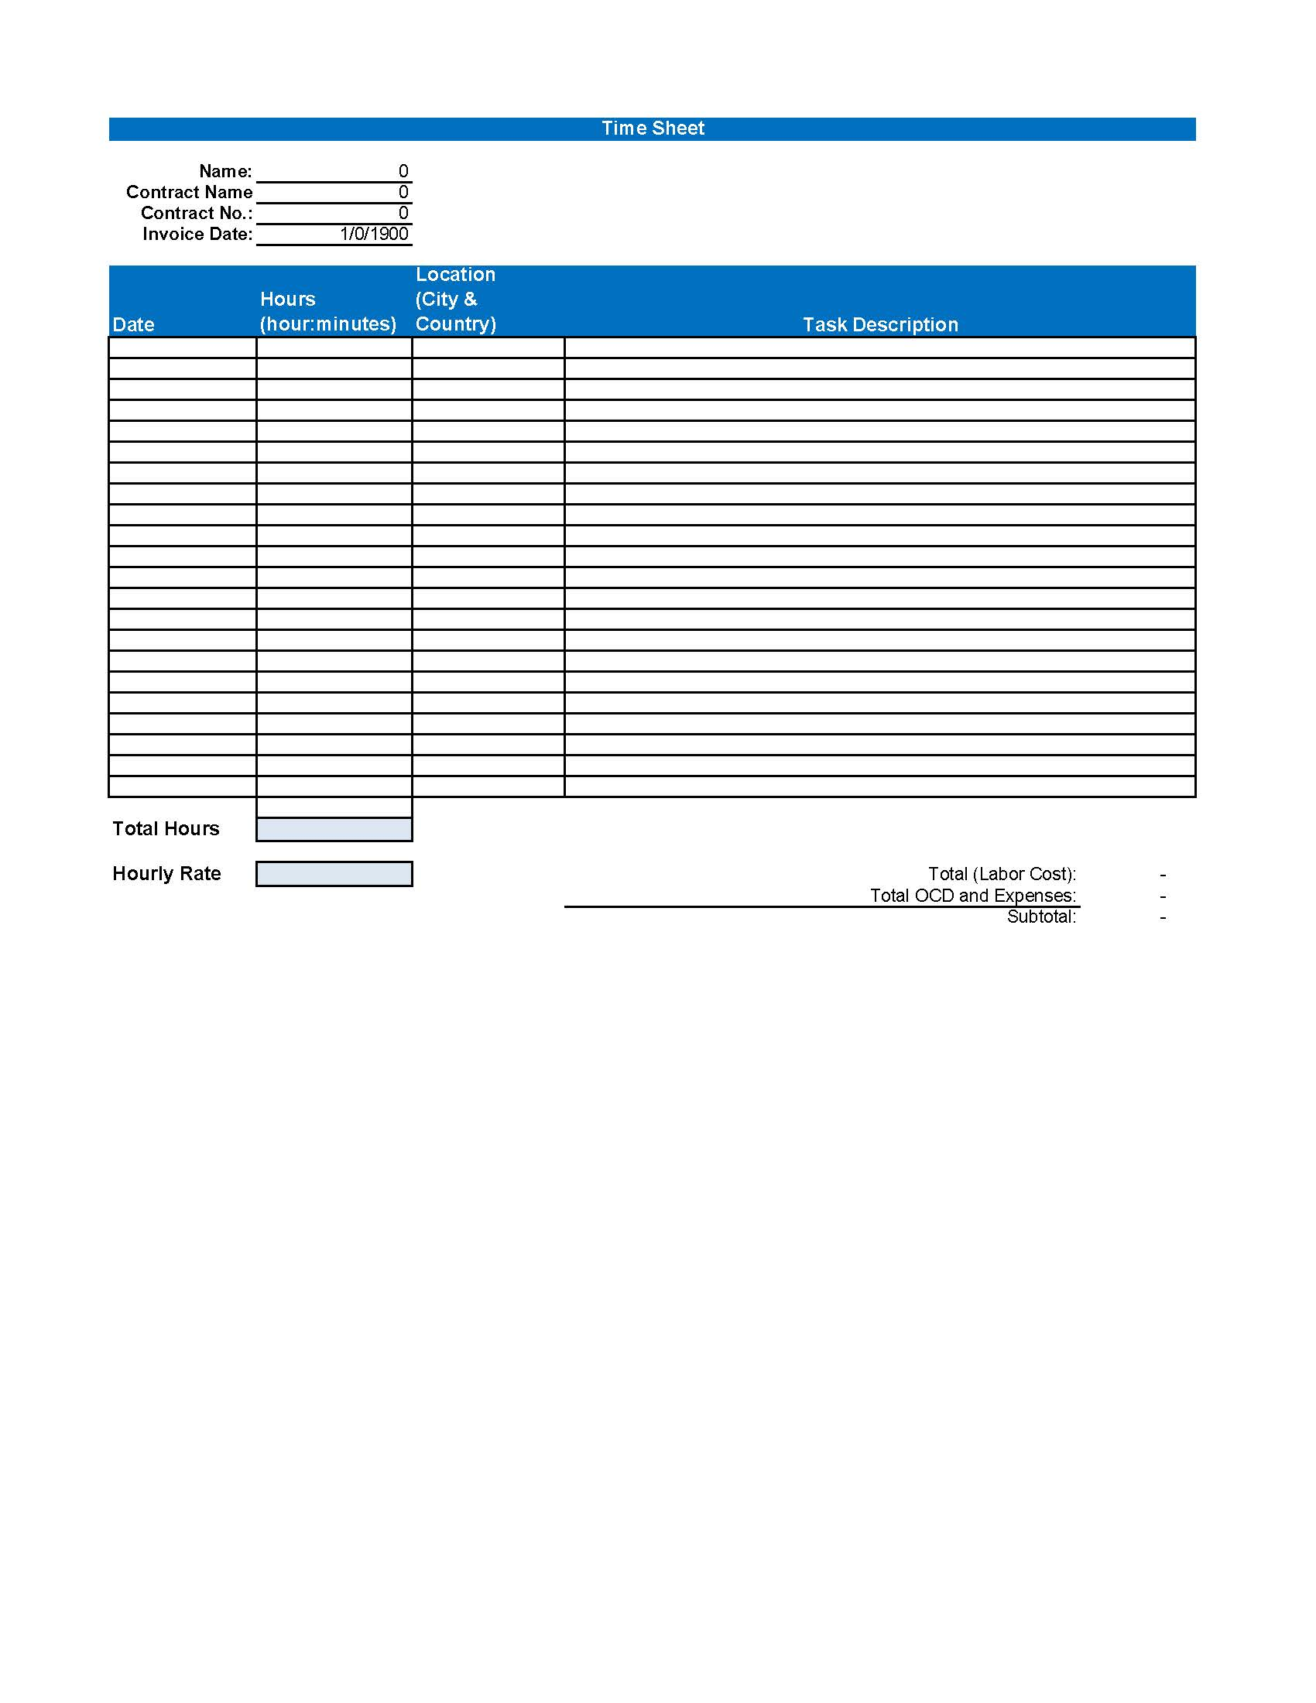

Attachment 2
Consultant Invoice Fixed Price Agreements
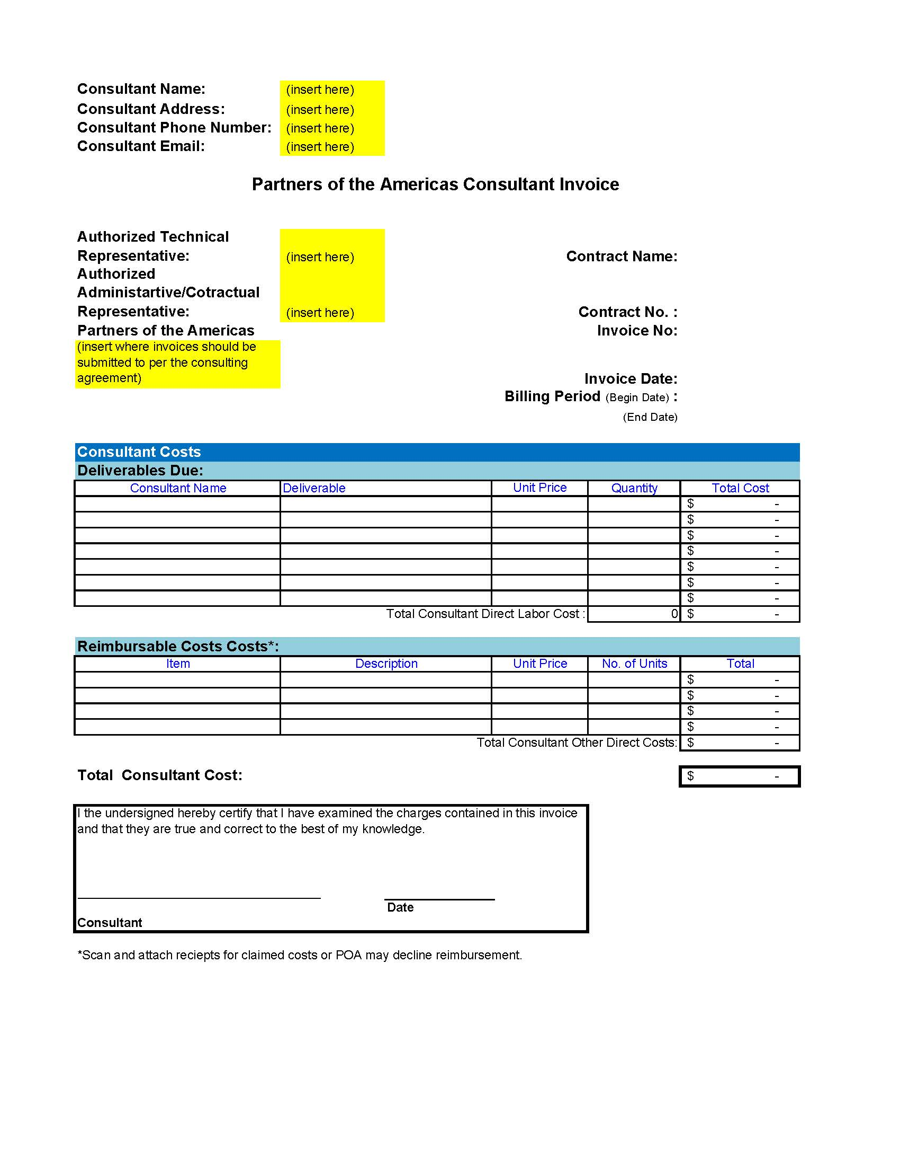

Per the UN Secretary-General’s Bulletin (ST/SGB/2003/13), sexual exploitation is defined as “any actual or attempted abuse of a position of vulnerability, differential power, or trust, for sexual purposes, including, but not limited to, profiting monetarily, socially or politically from the sexual exploitation of another.” Sexual abuse is defined as “the actual or threatened physical intrusion of a sexual nature, whether by force or under unequal or coercive conditions.”

